Nalongsone Danddank Student ID : 14958950 StarID: jf3893pd

Email: [nalongsone.danddank@my.metrostate.edu](mailto:nalongsone.danddank@my.metrostate.edu)

Homework 6 (*13.9/15* pts)[1]

1. [5.9/6 pts]: Perform an A* search to find the shortest path from San Franscisco to Atlanta in the attached graph. The first graph shows the distances between cities. The second graph shows the heuristic distances from each other city to Atlanta. Show your answer by filling out the table on the next page as done in Appendix A (and as shown in class on Feb 22).

This is a version of file F2b from Deliverable B, with some links removed, and the abbreviations reduced to one letter each.

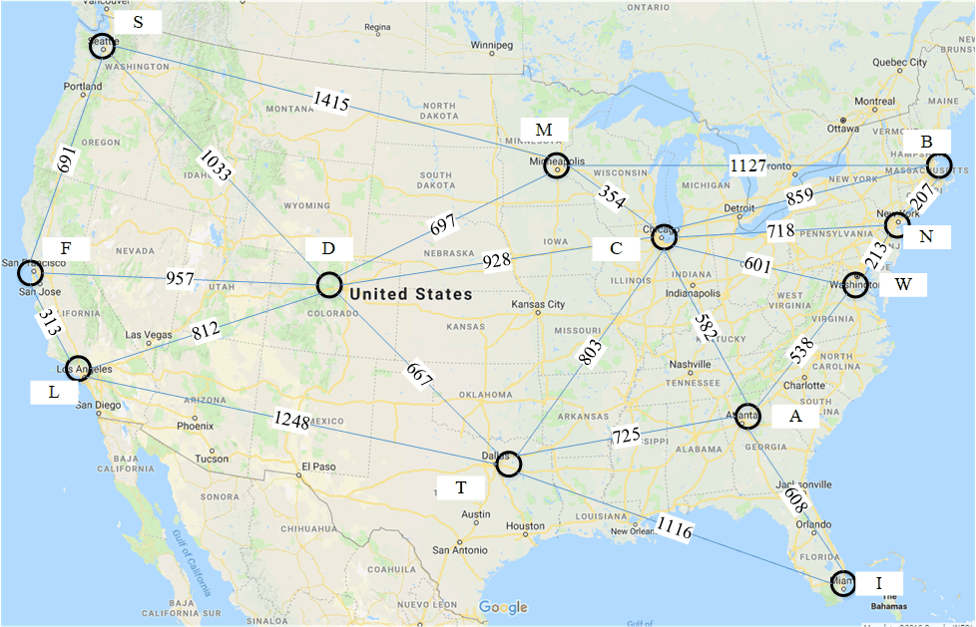

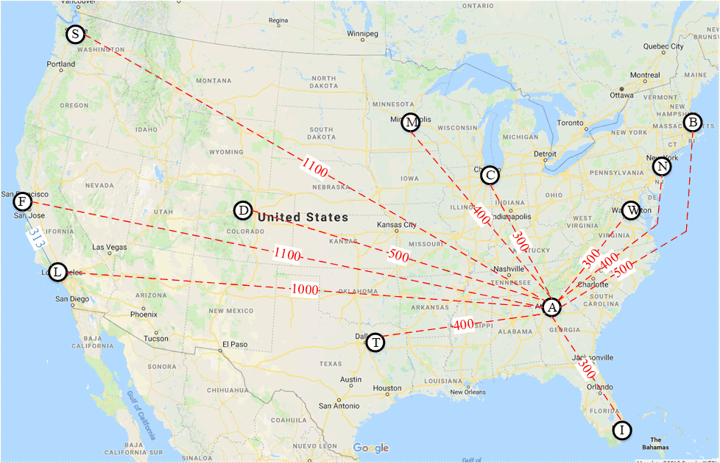

|  |  |  |  |  |  |  |  |  |  |  |  |  |  |  |  |
| --- | --- | --- | --- | --- | --- | --- | --- | --- | --- | --- | --- | --- | --- | --- | --- |
| Node | Priority Queue after Expanding Node (only 1st pos fixed) | | | | | | | | | | | | | | |
| node | f | path | node | f | path | node | f | path | node | f | path | node | f | path |
| F | L | 1313 | F | D | 1457 | F | S | 1791 | F |  |  |  |  |  |  |
| L | D | 1457 | F | S | 1791 | F | T | 1961 | FL |  |  |  |  |  |  |
| D | S | 1791 | F | T | 1961 | FL | M | 2054 | FD | C | 2185 | FD |  |  |  |
| S | T | 1961 | FL | M | 2054 | FD | C | 2185 | FD |  |  |  |  |  |  |
| T | M | 2054 | FD | C | 2185 | FD | A | 2286 | FLT | I | 2977 | FLT |  |  |  |
| M | C | 2185 | FD | A | 2286 | FLT | I | 2977 | FLT | B | 3281 | FDM |  |  |  |
| C | A | 2286 | FLT | W | 2786 | FDC | I | 2977 | FLT | N | 3003 | FDC | B | 3281 | FDM |
|  |  |  |  |  |  |  |  |  |  |  |  |  |  |  |  |

1. [2/6 pts]: Iterative Deepening: SF 🡪 Atl. Using the same graph as above, P\perform an iterative deepening heuristic depth first search (H-DFS w/ID)to locate a path from San Francisco to Atlanta. Stop when you find the first path. The heuristic is that whenever you have a choice of two or more nodes to visit, visit the nearer node. Begin searching at a depth of one node. Deepen the search by one node each time. Print the nodes visited as shown in Appendix B for each depth of search (depth 1, depth 2, and depth 3). ***See Appendix B.***



Solution: *Depth 1 search correct. Rest not.*

Depth 1 search:

F

L S D

Depth 2 search:

F

D

T M C

Depth 3 search:

F

D

T

A

Path: F D T A

1. [6/6 pts]: Prove that a linear combination of admissible, consistent heuristics is an admissible, consistent heuristic. That is, if h1(n) and h2(n) are heuristics, then prove that for any a in the open interval (0,1):
   * Part A: Prove h(n) = ah1(n) + (1-a)h2(n) is admissible.

We have h(n) is admissible if h(n) <= cost(n)

So h1(n) <=cost(n)

And h2(n) <= cost(n)

Add them together h1(n) + h2(n) <= 2*cost(n)

Than we get 1/2*h1(n) + 1/2*h2(n) <= cost(n)

And than 1/2*h1(n) + (1-1/2)*h2(n) <= cost(n)

We can see that: **a** = 1/2 in interval (0,1)

So Prove that h(n) = ah1(h) + (1-a)h2(n) is **admissible**, for any **a** in the open interval (0,1).

* + Part B: Prove h(n) = ah1(n) + (1-a)h2(n) is consistent.

We have h(n) is consistent heuristics if h(n) <= h(n’) + cost(n’)

So h1(n) <= h1(n’) + cost1(n’)

And h2(n) <= h2(n’) + cost2(n’)

Add them together h1(n) + h2(n) <= h1(n’) + h2(n’) + cost1(n’) + cost2(n’)

also have h(n’) <= cost(n’) h1(n) + h2(n) <= cost1(n’) + cost2(n’) +cost1(n’) + cost2(n’)

h1(n) + h2(n) <= 2*(cost1(n’) + cost2(n’))

1/2*h1(n) + (1-1/2)*h2(n) <= cost1(n’) + cost2(n’)

We can see that: **a** = 1/2 in interval (0,1)

So Prove that h(n) = ah1(h) + (1-a)h2(n) is **consistent**, for any **a** in the open interval (0,1).

**Appendix A: A* Search example**

|  |  |  |  |  |  |  |  |  |  |  |  |  |
| --- | --- | --- | --- | --- | --- | --- | --- | --- | --- | --- | --- | --- |
| node | Priority queue after expanding node (only 1st pos fixed) | | | | | | | | | | | |
| Node | f | path | Node | f | path | Node | f | path | Node | f | path |
| S | A | 5 | S | B | 5 | S |  |  |  |  |  |  |
| A | B | 5 | S | C | 8 | SA | D | 8 | SA |  |  |  |
| B | E | 7 | SB | C | 8 | SA | D | 8 | SA | F | 10 | SB |
| E | C | 8 | SA | D | 8 | SA | G | 8 | SBE | F | 10 | SB |
| C | D | 8 | SA | G | 8 | SBE | F | 10 | SB |  |  |  |
| D | G | 8 | SBE | F | 10 | SB |  |  |  |  |  |  |
| G |  |  |  |  |  |  |  |  |  |  |  |  |

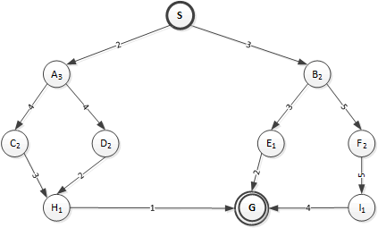

**Appendix B: Heuristic Depth First Search with Iterative Deepening (H-DFS w/ID) example**

L

let’s take the same file that you will be using, but we will do the H-DFS w/ID from Minneapolis (M) to Miami (I). I list the nodes in the order in which I discover them.



Depth 1 search: (1st row is node at depth 0, second row is nodes at depth 1)

M

C D B S

Depth 2 search: (added row is nodes at depth 2, under the node they were discovered from, so A W N T B and D were discovered from C, and F was discovered from S)

M

C S

A W N T B D F

Depth 3 search: (added row is nodes at depth 3, we stop when we discover F the goal)

M

C

A

W I

Path: M C A I

1. Note that > 15 points are possible, so basically this homework includes a little extra credit.